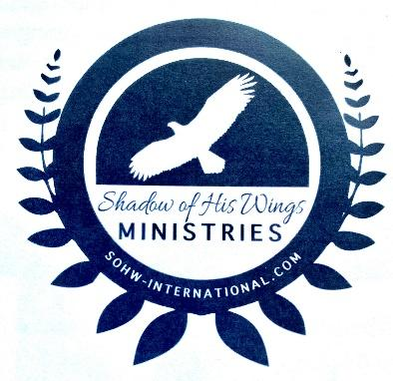
Shadow of His Wings Ministry
1st Annual Spring Craft Fair FUNDRAISER
Aztec High School Multipurpose Building
500 E Chaco St. Aztec, NM 87410
Saturday June 1, 2024 from 9 am-4 pm

Join with us to help raise funds to clothe, educate, provide food, and minister to the Widows and Orphans in Kenya, Africa.
- Small booth (8x10) $25.00 Large Booth (8x20) $50.00
- One booth item to raffle
- Only one Multi-Level Marketing Booth per company
- You will need to bring your own tables and chairs
- Vendors may setup on Friday May 31 from 5 pm-9 pm
Shadow of His Wings will sell food, baked goods, and drinks during the craft fair. Booth rental and concession proceeds will help SOHW with the ministry in Kenya.
- Questions? Email Brenda Liesse at lala2897@outlook.com
--------------------------------------------------------------------------------------------------------------
Contact Name ___________________ Phone # _____________________
Vendor Name _________________________________________________
E-mail Address ________________________________________________
Small Booth ($25.00) ____________ Large Booth ($50.00) _____________
Booth Setup and Product Description_______________________________
_____________________________________________________________
--------------------------------------------------------------------------------------------------------------
Make Checks payable to SOHW. Please mail checks and application form to Shadow of His Wings
Attn: Brenda Liesse
PO Box 761 Aztec, NM 87410
You can, also, contact Brenda Liesse at 505-860-4872 during the hours of 4 - 8 pm for credit card payments or vendor registration.
- Payment and Registration Form due by March 31st to assure best availability

